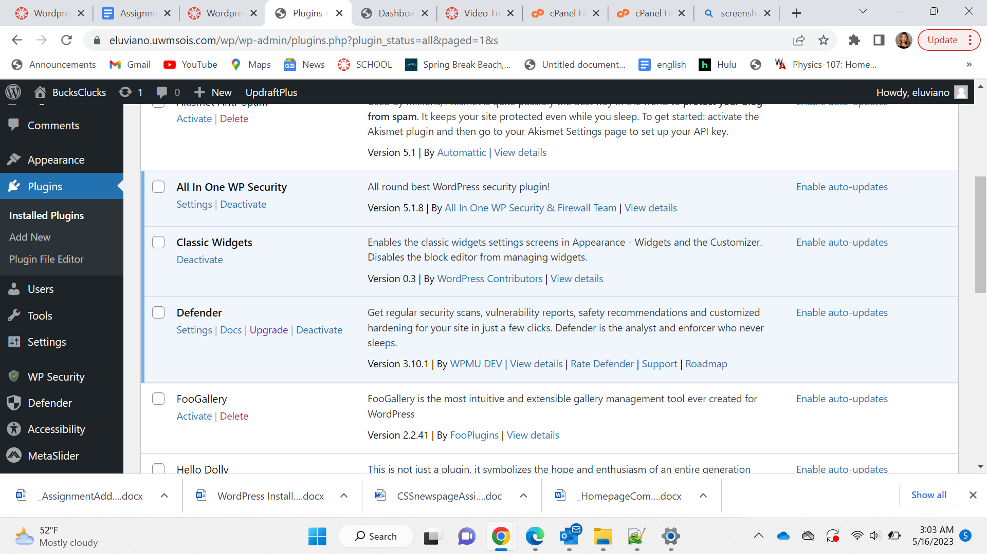

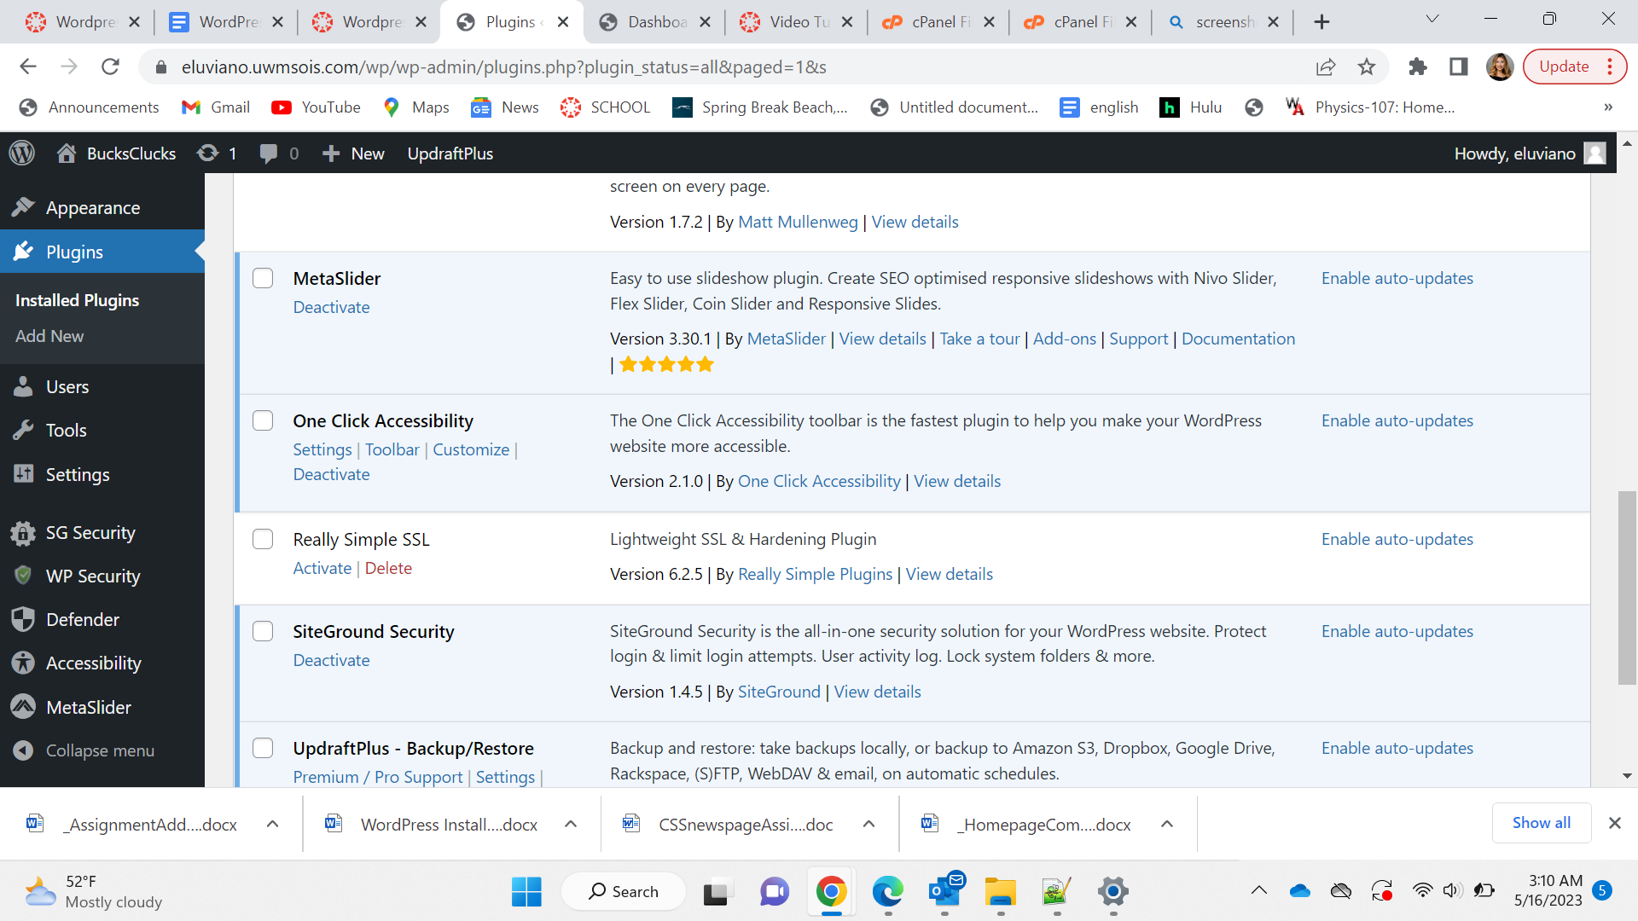

All In One:

This security plugin has an average five star rating with over one million downloads giving it a sense of legibility. Giving an automatic protection from bots and security threats that may harm the website. The content protection feature within this plugin allows for protection from spam comments and other websites stealing information from content.

SiteGround Security:

This security plugin allows for authors to use the curated list created by the plugin that is of the “Recommended Vulnerabilities Protection Settings” retaining the safety of the website's security. The login access is limited to a specific ip address through this plugin. Therefore decreasing the amount of scammers coming across your page.

Defender Security:

This security plugin gives great recommendations regarding the security of your website and what would work best for your content without going through the hassle of the use of such complex security settings. An example being the two factor authorization that decreases hackers from stealing your information.